TECHNOLOGY ARCHITECTURE

|  |  |
| --- | --- |
| Date | 14 November 2022 |
| Team ID | PNT2022TMID52418 |
| Project Name | AI-based localization and classification of skin disease with erythema |
| Maximum Marks | 4 Marks |

**Technical Architecture:**

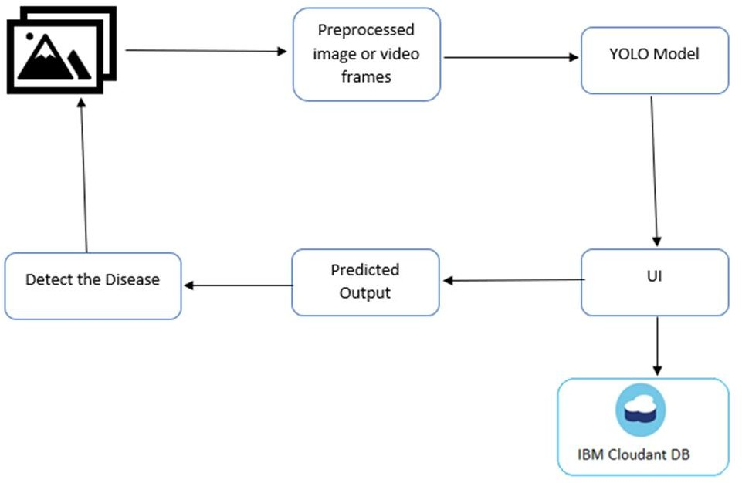

Table-1: Components & Technologies:

|  |  |  |  |
| --- | --- | --- | --- |
| **S.No** | **Component** | **Description** | **Technology** |
| 1. | User Interface | How user interacts with application e.g., Web UI, Chatbot etc. | HTML, CSS, JavaScript |
| 2. | Application Logic-1 | The data of the users will be stored in the data base. | Python |
| 3. | Application Logic-2 | Logic for a process in the application | IBM Watson Assistant |
| 4. | Cloud Database | Database Service on Cloud | IBM Cloudant |
| 5. | Machine Learning Model | Purpose of Machine Learning Model | Object Recognition Model |
| 6. | Infrastructure (Server / Cloud) | Application Deployment on Cloud Server Configuration | Kubernetes |

Table-2: Application Characteristics:

|  |  |  |  |
| --- | --- | --- | --- |
| **S.No** | **Characteristics** | **Description** | **Technology** |
| 1. | Open-Source Frameworks | List the open-source frameworks used | Keras |
| 2. | Security Implementations | List all the security / access controls implemented, use of firewalls etc. | Encryptions |
| 3. | Scalable Architecture | Justify the scalability of architecture | 3-Tier Architecture |